**BIG TASK 2_MAUNDING RISMA**

1. **PROBLEM 1_JAM PASIR**

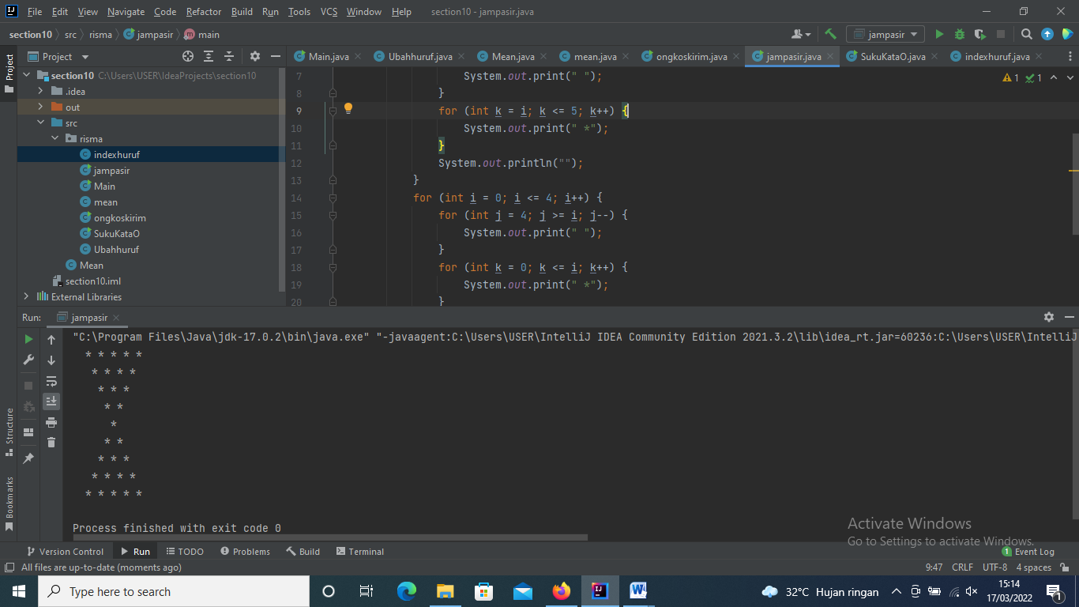

1. **PROBLEM 2_SUKU KATA O**

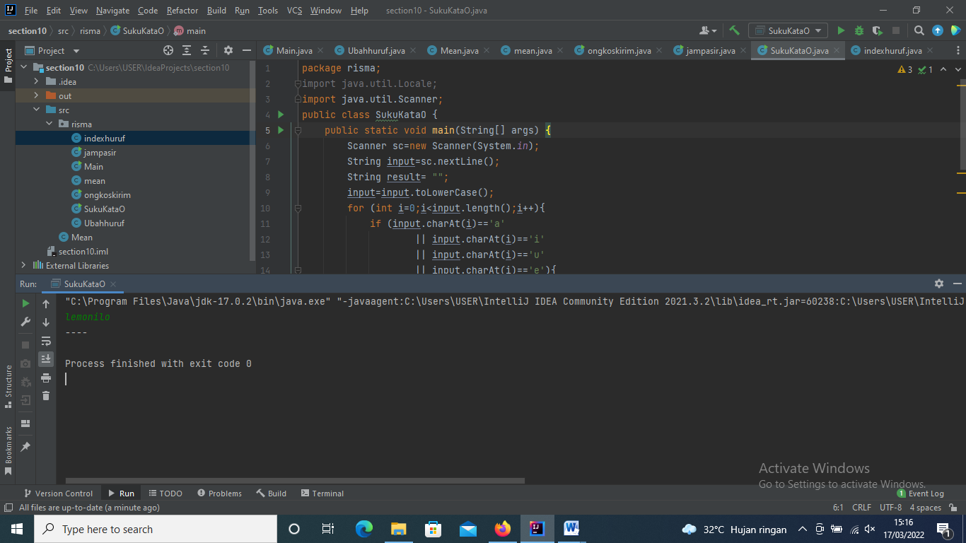

1. **PROBLEM 4_INDEX HURUF**

